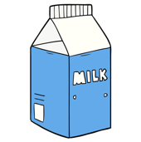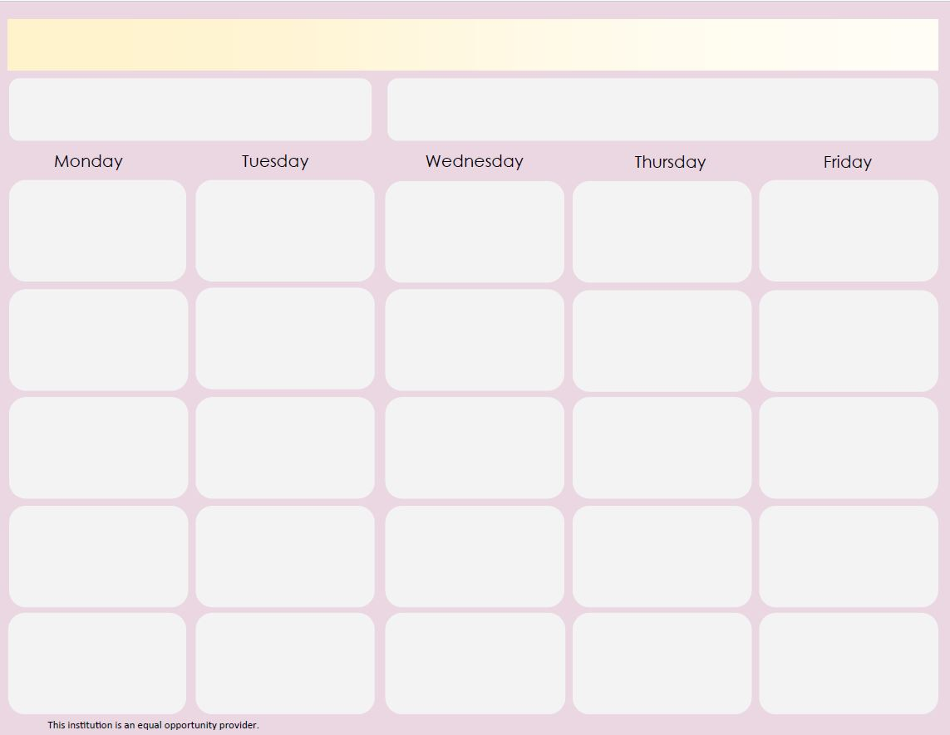

K-8 Cold Breakfast Menuunch

WG Reduced-Sugar Cinnamon Toast Crunch

WG Assorted Graham Cracker

100% Juice Cup

Seasonal Fruit

Choice of Milk

March 2020

**Nutrition tip:** Pineapples are high in Vitamin C, B Vitamins, minerals and antioxidants that can help boost overall health!

Reference: www.medicalnewstoday.com

NEW! WG Appleways Granola Bites

Yogurt Cup

100% Juice Cup

Seasonal Fruit

Choice of Milk

WG Cinnamon Chex

Cheese Stick

100% Juice Cup

Seasonal Fruit

Choice of Milk

WG General Mills Cereal Bars

WG Assorted Cereal or Cracker

100% Juice Cup

Seasonal Fruit

Choice of Milk

WG Granola

Yogurt Cup

100% Juice Cup

Seasonal Fruit

Choice of Milk

WG Cinnamon Flakes

Cheese Stick

100% Juice Cup

Seasonal Fruit

Choice of Milk

WG UBR Bar

100% Juice Cup

Seasonal Fruit

Choice of Milk

WG Cheerios

WG Assorted Graham Cracker

100% Juice Cup

Seasonal Fruit

Choice of Milk

Whole Grain Breakfast Bread

100% Juice Cup

Seasonal Fruit

Choice of Milk

WG Mini Cinnis

100% Juice Cup

Seasonal Fruit

Choice of Milk

WG Frosted Mini Wheats

WG Assorted Graham Cracker

100% Juice Cup

Seasonal Fruit

Choice of Milk

Whole Grain Breakfast Muffin

Cheese Stick

100% Juice Cup

Seasonal Fruit

Choice of Milk

WG Reduced-Sugar Cocoa Puffs

WG Assorted Graham Cracker

100% Juice Cup

Seasonal Fruit

Choice of Milk

WG Dunker Bar

100% Juice Cup

Seasonal Fruit

Choice of Milk

WG Gripz Cinnamon Grahams

Cheese Stick

100% Juice Cup

Seasonal Fruit

Choice of Milk

WG Multigrain Cheerios

WG Assorted Graham Cracker

100% Juice Cup

Seasonal Fruit

Choice of Milk

WG Cream Cheese-Filled Bagels

100% Juice Cup

Seasonal Fruit

Choice of Milk

WG Grape Jelly Crescents

100% Juice Cup

Seasonal Fruit

Choice of Milk

NEW! WG Frosted Flakes

WG Assorted Graham Cracker

100% Juice Cup

Seasonal Fruit

Choice of Milk

NEW! WG Cinnamon Toast

Crunch Soft Filled Bread

100% Juice Cup

Seasonal Fruit

Choice of Milk

WG Cinnamon Chex

Cheese Stick

100% Juice Cup

Seasonal Fruit

Choice of Milk

WG General Mills Cereal Bars

WG Assorted Cereal or Cracker

100% Juice Cup

Seasonal Fruit

Choice of Milk

**Daily Milk:**

Skim white

Low fat white

Skim Chocolate

Stellar Elementary